Reg No:1911260108
Name: SHANUKA

Date:

EXPERIMENT-1 CONFIGURATION OF NETWORK COMPONENTS

Aim: To Study the following Network Devices in Detail
- PC
- Server
- Repeater
- Hub
- Switch
- Bridge
- Router
- Gate Way
- Transmission medium

Apparatus (Software): CISCO Packet tracer.

- Node: In a communications network, a network node is a connection point that can receive, create, store or send data along distributed network routes.
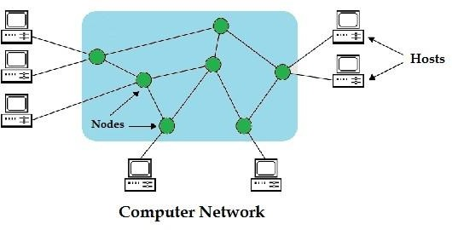
- Repeater: Functioning at Physical Layer.
A repeater is an electronic device that receives a signal and retransmits it at a higher level and/or higher power, or onto the other side of an obstruction, so that the signal can cover longer distances.
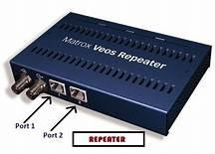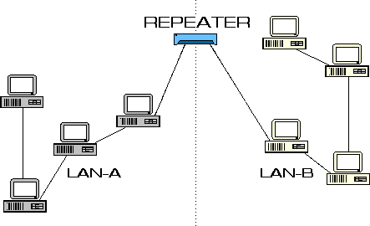

Hub: Ethernet hub, active hub, network hub, repeater hub
Hub or concentrator is a device for connecting multiple twisted pair or fiber optic Ethernet devices together and making them act as a single network segment. Hubs work at the physical layer (layer 1) of the OSI model. The device is a form of multiport repeater. Repeater hubs also participate in collision detection, forwarding a jam signal to all ports if it detects a collision.
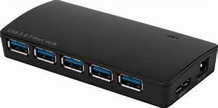
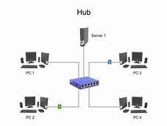

- Switch: A network switch or switching hub is a computer networking device that connects network segments. The term commonly refers to a network bridge that processes and routes data at the data link layer (layer 2) of the OSI model. Switches that additionally process data at the network layer (layer 3 and above) are often referred to as Layer 3 switches or multilayer switches.
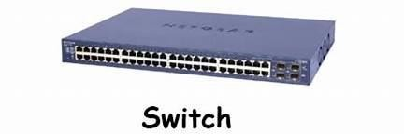
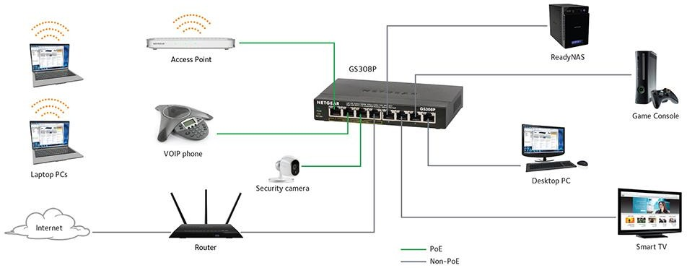

- Bridge: A network bridge connects multiple network segments at the data link layer (Layer 2) of the OSI model. In Ethernet networks, the term bridge formally means a device that behaves according to the IEEE 802.1D standard. A bridge and switch are very much alike; a switch being a bridge with numerous ports. Switch or Layer 2 switch is often used interchangeably with bridge. Bridges can analyze incoming data packets to determine if the bridge is able to send the given packet to another segment of the network.
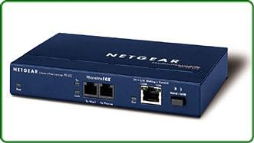

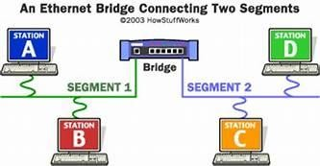

- Router: A router is an electronic device that interconnects two or more computer
networks, and selectively interchanges packets of data between them. Each data packet contains address information that a router can use to determine if the source and destination are on the same network, or if the data packet must be transferred from one network to another. The multiple routers are used in a large collection of interconnected networks, the routers exchange information about target system addresses, so that each router can build up a table showing the preferred paths between any two systems on the interconnected networks.
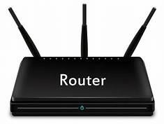

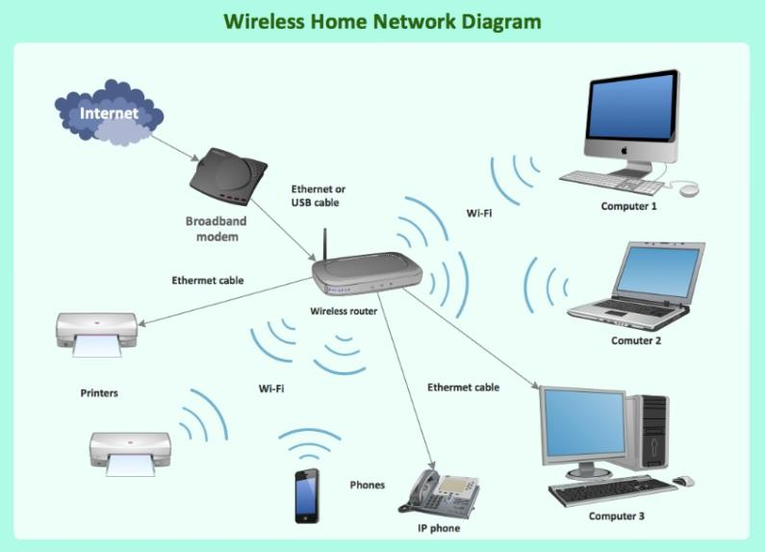
- Gate Way: In a communication network, a network node equipped for interfacing with another network that uses different protocols. A gateway may contain devices such as protocol translators, impedance matching devices, rate converters, fault isolators, or signal translators as necessary to provide system interoperability. It also requires the establishment of mutually acceptable administrative procedures between both networks.
  - A protocol translation/mapping gateway interconnects networks with different network protocol technologies by performing the required protocol conversions.
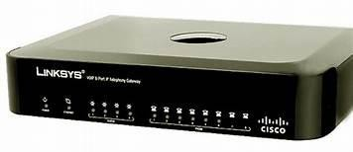

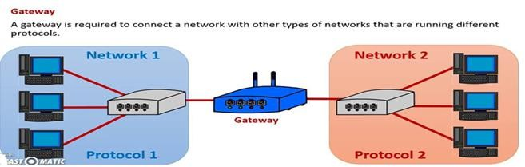
- Server: A server is a type of computer or device on a network that manages network resources. Servers are often dedicated, meaning that they perform no other tasks besides their server tasks. On multiprocessing operating systems, however, a single computer can execute several programs at once. A server in this case could refer to the program that is managing resources rather than the entire computer.

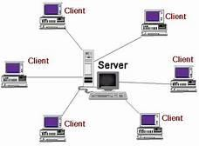
- Transmission media: The medium through which the signals travel from one device to another. These are classified as guided and unguided. Guided media are those that provide a conduit from one device to another. Eg. Twisted pair, coaxial cable etc. Unguided media transport signals without using physical cables. Eg. Air.
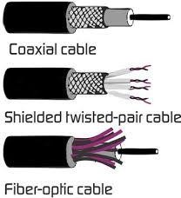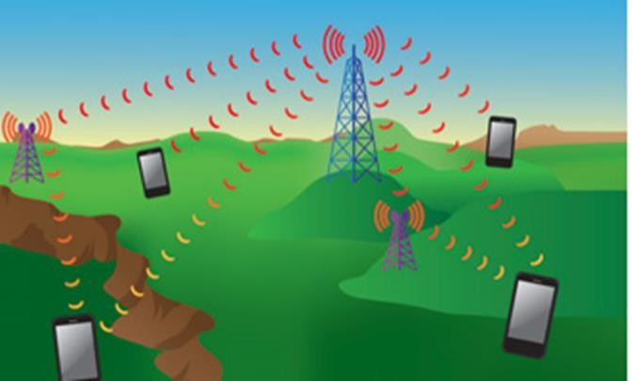

Result: Thus the network components are studied in detail.
Date:

EXPERIMENT-2
IMPLEMENTATION OF STAR TOPOLOGY USING PACKET TRACER

Aim: To Implement a star topology using packet tracer and hence to transmit data between the devices connected using star topology.
Software/Apparatus required: Packet Tracer/End devices, bridge, connectors.
Steps for building topology:
Step 1: Start Packet Tracer
Step 2: Choosing Devices and Connections Step 3: Building the Topology – Adding Hosts
Single click on the End Devices. Single click on the Generic host. Move the cursor into topology area.
Single click in the topology area and it copies the device.

Step 4: Building the Topology – Connecting the Hosts to Switches
Select a switch, by clicking once on Switches and once on a 2950-24 switch. Add the switch by moving the plus sign “+”

Step 5: Connect PCs to switch by first choosing Connections
Click once on the Copper Straight-through cable Click once on PC2
Choose Fast Ethernet Drag the cursor to Switch0 Click once on Switch0
Notice the green link lights on PC Ethernet NIC and amber light Switch port. The switch port is temporarily not forwarding frames, while it goes through the stages for the Spanning Tree Protocol (STP) process. After about 30 seconds the amber light will change to green indicating that the port has entered the forwarding stage. Frames can now forwarded out the switch port.

Step 6: Configuring IP Addresses and Subnet Masks on the Hosts
To start communication between the hosts IP Addresses and Subnet Masks had to be Configured on the devices. Click once on PC0. Choose the Config tab and click on
FastEthernet0. Type the IP address in its field. Click on the subnet mask it will be generated automatically.

Step 7: To confirm Data transfer between the devices
Click on the node. Select desktop option and then command prompt. Once the window
pops up, ping the IP address of the device to which node0 is connected. Ping statistics
will be
displayed.

Diagram:
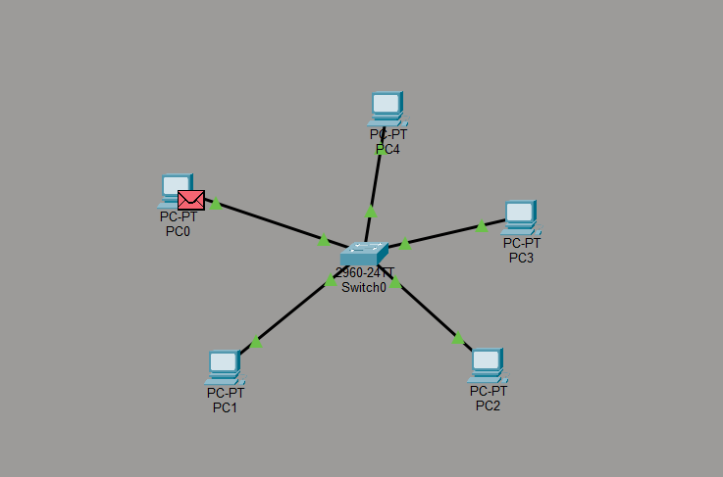

Output:
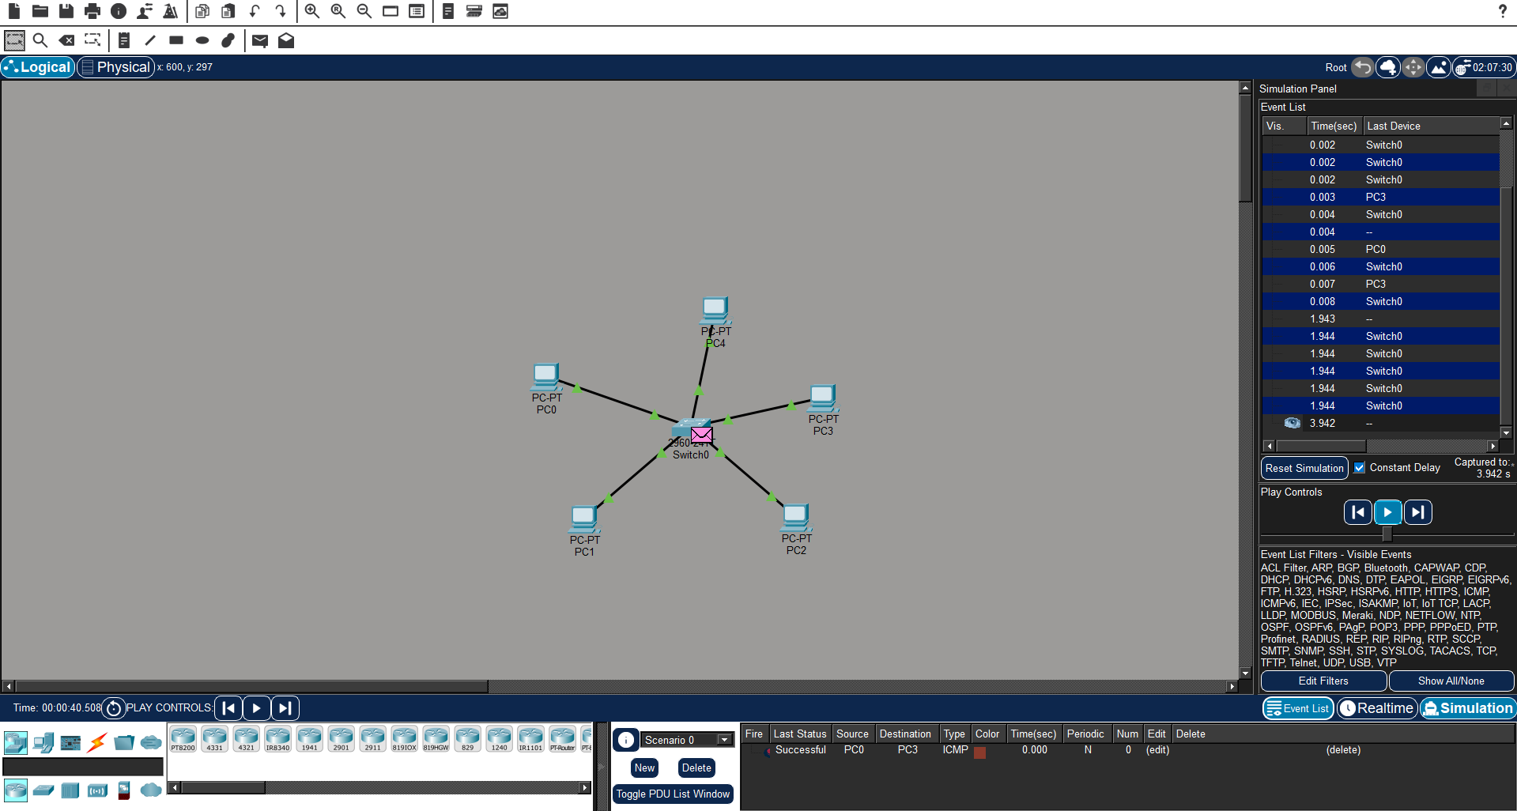

Result: Thus the Star topology is implemented with Packet Tracer simulation Tool.
Date:

EXPERIMENT-3
IMPLEMENTATION OF BUS TOPOLOGY USING PACKET TRACER

Aim: To Implement a Bus topology using packet tracer and hence to transmit data between the devices connected using Bus topology.
Software / Apparatus required: Packet Tracer / End devices, Hubs, connectors.
Steps for building topology:
Step 1: Start Packet Tracer
Step 2: Choosing Devices and Connections Step 3: Building the Topology – Adding Hosts
Single click on the End Devices. Single click on the Generic host. Move the cursor into topology area.
Single click in the topology area and it copies the device.

Step 4: Building the Topology – Connecting the Hosts to Switches
Select a switch, by clicking once on Switches and once on a 2950-24 switch. Add the switch by moving the plus sign “+”

Step 5: Connect PCs to switch by first choosing connections
Click once on the Copper Straight-through cable Click once on PC2
Choose Fast Ethernet Drag the cursor to Switch0 Click once on Switch0
Notice the green link lights on PC Ethernet NIC and amber light Switch port. The switch port is temporarily not forwarding frames, while it goes through the stages for the Spanning Tree Protocol (STP) process. After about 30 seconds the amber light will change to green indicating that the port has entered the forwarding stage. Frames can now forward out the switch port.

Step 6: Configuring IP Addresses and Subnet Masks on the Hosts
To start communication between the hosts IP Addresses and Subnet Masks had to be configured on the devices. Click once on PC0. Choose the Config tab and click on FastEthernet0. Type the IP address in its field. Click on the subnet mask it will
be generated automatically.

Step 7: To confirm Data transfer between the devices
Click on the node. Select desktop option and then command prompt. Once the window pops up, ping the IP address of the device to which node0 is connected. Ping statistics will be displayed.

Diagram:
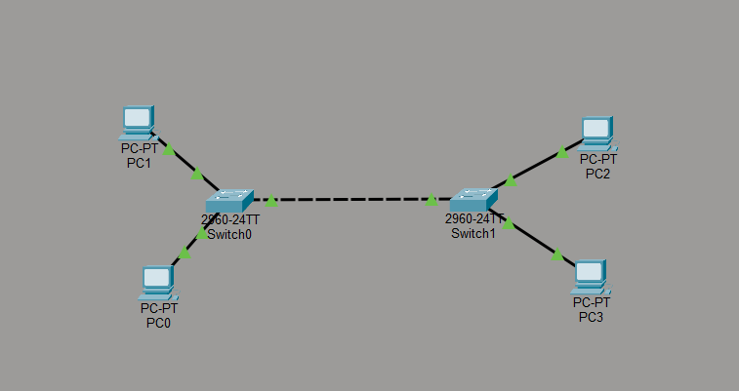

Output:

Output:
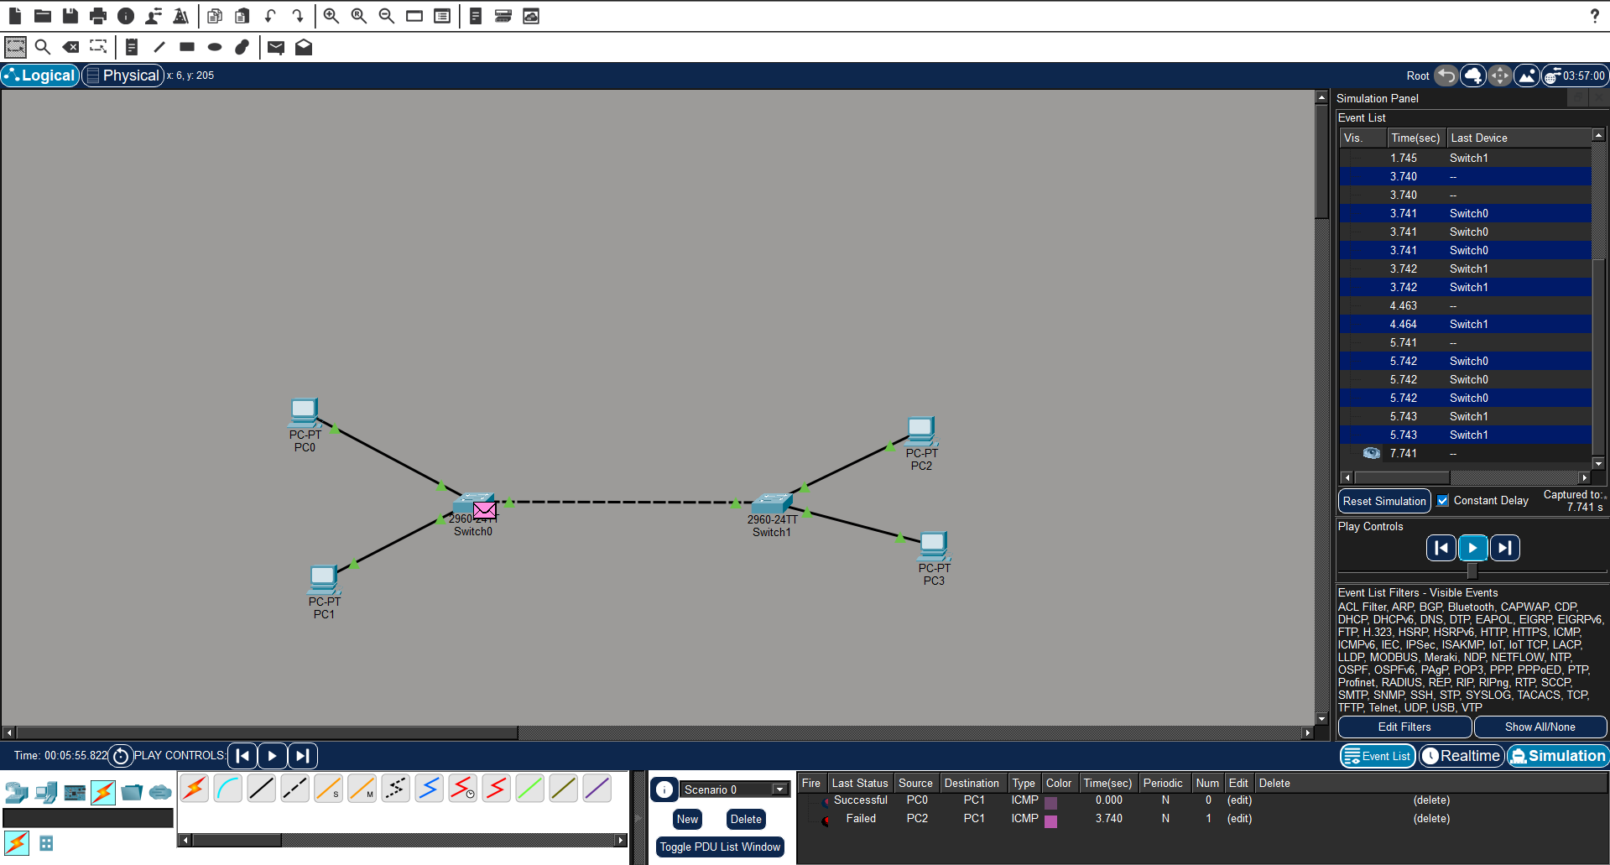

Result: Thus the Bus topology is implemented with Packet Tracer simulation Tool.
Date:

EXPERIMENT-4
IMPLEMENTATION OF RING TOPOLOGY USING PACKET TRACER

Aim: To Implement a Ring topology using packet tracer and hence to transmit data between the devices connected using Ring topology.
Software / Apparatus required: Packet Tracer / End devices, Hubs, Connectors.
Steps for building topology:
Step 1: Start Packet Tracer
Step 2: Choosing Devices and Connections Step 3: Building the Topology – Adding Hosts
Single click on the End Devices. Single click on the Generic host. Move the cursor into topology area.
Single click in the topology area and it copies the device.

Step 4: Building the Topology – Connecting the Hosts to Switches
Select a switch, by clicking once on Switches and once on a 2950-24 switch. Add the switch by moving the plus sign “+”

Step 5: Connect PCs to switch by first choosing connections
Click once on the Copper Straight-through cable Click once on PC2
Choose Fast Ethernet Drag the cursor to Switch0 Click once on Switch0
Notice the green link lights on PC Ethernet NIC and amber light Switch port. The switch port is temporarily not forwarding frames, while it goes through the stages for the Spanning Tree Protocol (STP) process. After about 30 seconds the amber light will change to green indicating that the port has entered the forwarding stage. Frames can now forward out the switch port.

Step 6: Configuring IP Addresses and Subnet Masks on the Hosts
To start communication between the hosts IP Addresses and Subnet Masks had to be configured on the devices. Click once on PC0. Choose the Config tab and click on FastEthernet0. Type the IP address in its field. Click on the subnet mask it will
be generated automatically.

Step 7: To confirm Data transfer between the devices
Click on the node. Select desktop option and then command prompt. Once the window pops up, ping the IP address of the device to which node0 is connected. Ping statistics will be displayed.

Diagram:

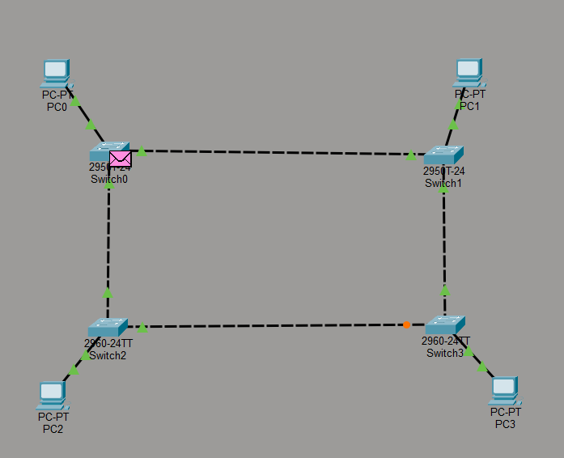

Output

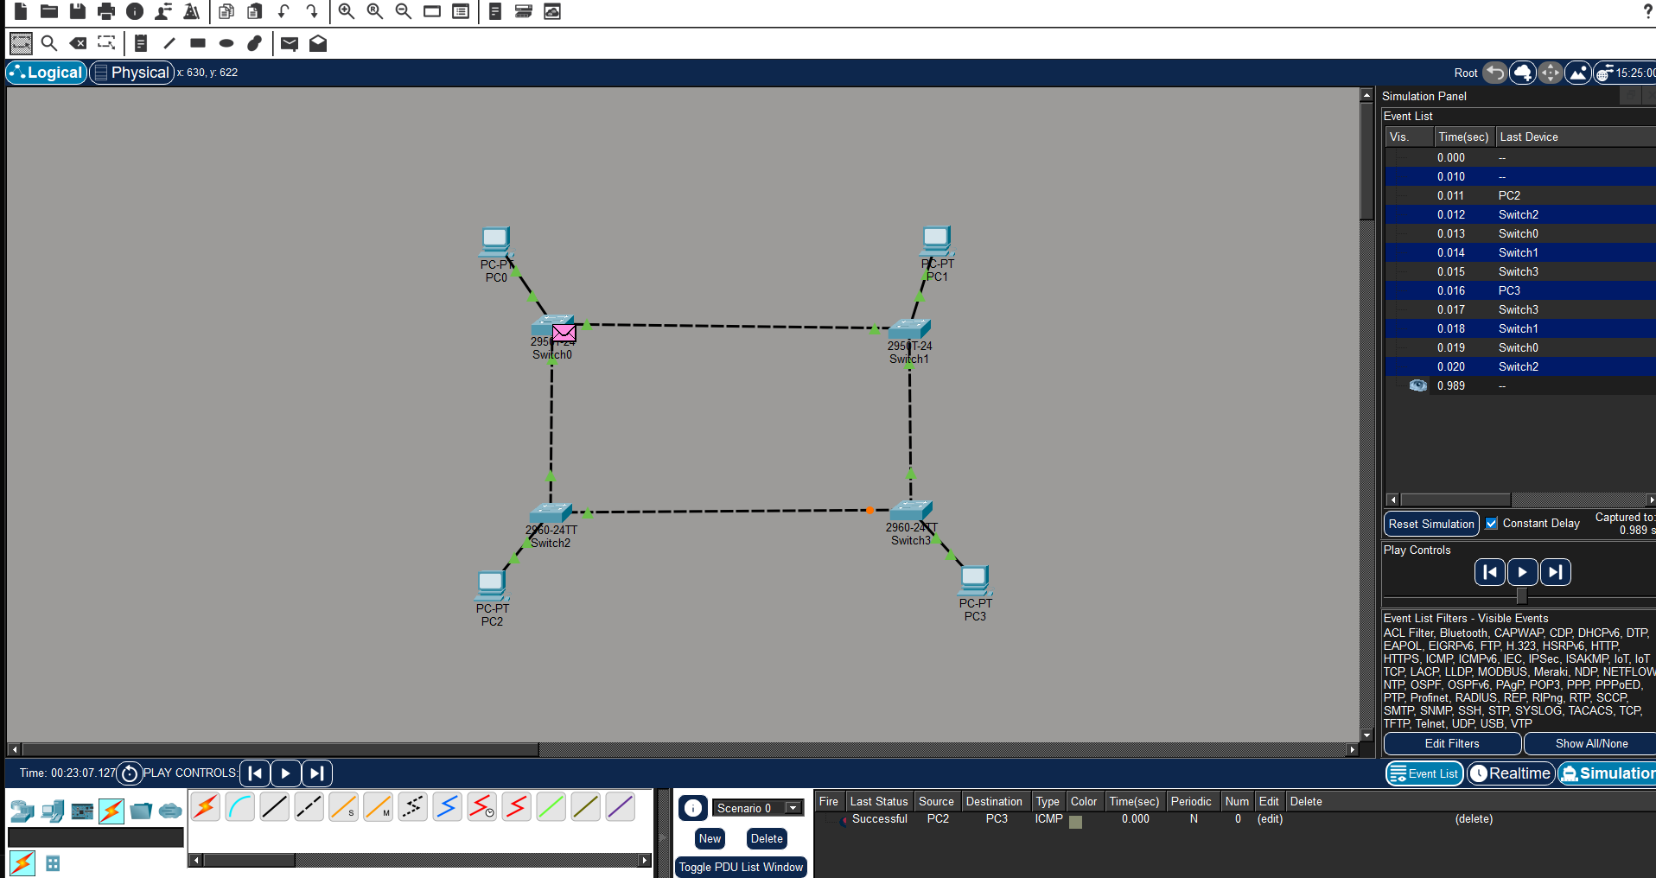

Result: Thus the Ring topology is implemented with Packet Tracer simulation Tool.
Date:

EXPERIMENT-5
IMPLEMENTATION OF MESH TOPOLOGY USING PACKET TRACER

Aim: To Implement a Mesh topology using packet tracer and hence to transmit data between the devices connected using Mesh topology.
Software / Apparatus required: Packet Tracer / End devices, Hubs, Connectors.
Steps for building topology:
Step 1: Start Packet Tracer
Step 2: Choosing Devices and Connections Step 3: Building the Topology – Adding Hosts
Single click on the End Devices. Single click on the Generic host. Move the cursor into topology area.
Single click in the topology area and it copies the device.

Step 4: Building the Topology – Connecting the Hosts to Switches
Select a switch, by clicking once on Switches and once on a 2950-24 switch. Add the switch by moving the plus sign “+”

Step 5: Connect PCs to switch by first choosing connections
Click once on the Copper Straight-through cable Click once on PC2
Choose Fast Ethernet Drag the cursor to Switch0 Click once on Switch0
Notice the green link lights on PC Ethernet NIC and amber light Switch port. The switch port is temporarily not forwarding frames, while it goes through the stages for the Spanning Tree Protocol (STP) process. After about 30 seconds the amber light will change to green indicating that the port has entered the forwarding stage. Frames can now forward out the switch port.

Step 6: Configuring IP Addresses and Subnet Masks on the Hosts
To start communication between the hosts IP Addresses and Subnet Masks had to be configured on the devices. Click once on PC0. Choose the Config tab and click
on FastEthernet0. Type the IP address in its field. Click on the subnet mask it will be generated automatically.

Step 7: To confirm Data transfer between the devices
Click on the node. Select desktop option and then command prompt. Once the window pops up, ping the IP address of the device to which node0 is connected. Ping statistic will be displayed.

Diagram:

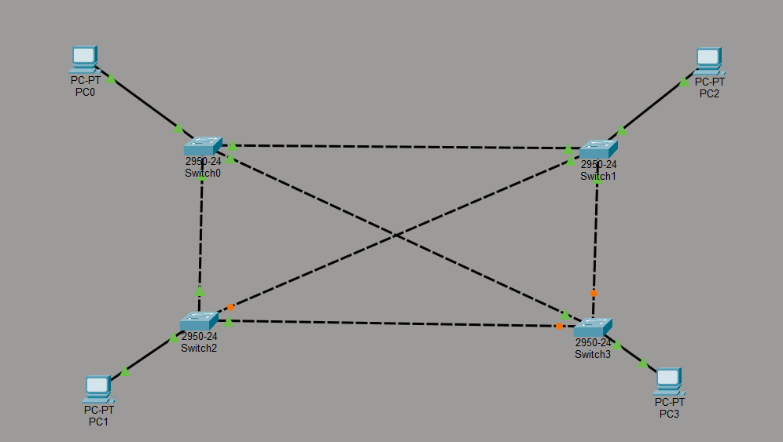

Output:

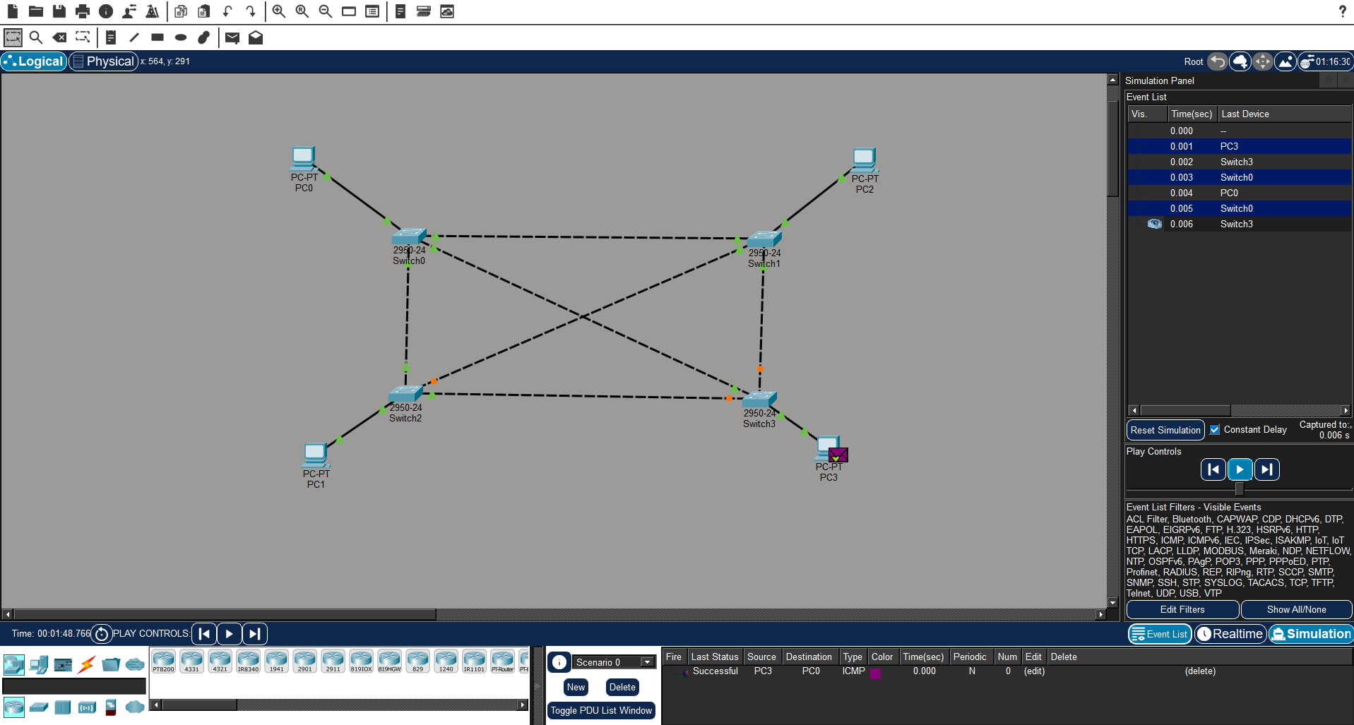

Result: Thus the Mesh topology is implemented with Packet Tracer simulation Tool.

Date:

EXPERIMENT-6
IMPLEMENTATION OF TREE TOPOLOGY USING PACKET TRACER
Aim: To Implement a tree topology using packet tracer and hence to transmit data between the devices connected using tree topology.
Software / Apparatus required: Packet Tracer / End devices, Hubs, connectors.
Procedure:
Steps for building topology:
Step 1: Start Packet Tracer
Step 2: Choosing Devices and Connections Step 3: Building the Topology – Adding Hosts
Single click on the End Devices. Single click on the Generic host. Move the cursor into topology area.
Single click in the topology area and it copies the device.
Step 4: Building the Star Topology – Connecting the Hosts to Hubs Select a Hub, by clicking once on Hub and once on a generic Hub Add the Hub by moving the plus sign “+”

Step 5: Connect PCs to Hub by first choosing Connections
Click once on the Automatic cable selector
Click once on PC2 Choose Fast Ethernet Drag the cursor to Hub0 Click once on Hub0

Proceeding in this way create three star topologies
Step 6: Building the Tree Topology – Connecting the Hubs to Active Hub
Connect the hubs of star topologies to active hub to create tree topology.

Step 7: Configuring IP Addresses and Subnet Masks on the Hosts
To start communication between the hosts IP Addresses and Subnet Masks had to be configured on the devices. Click once on PC0. Choose the Config tab and click on Fast Ethernet0. Type the IP address in its field. Click on the subnet mask. It will be
generated automatically.

Step 8: Verifying Connectivity in Real time Mode
Be sure you are in Real time mode.
Select the Add Simple PDU tool used to ping devices. Click once on PC0, then once on PC3.
The PDU Last Status should show as Successful.

Step 9: Verifying Connectivity in Simulation Mode
Be sure you are in Simulation mode.
Deselect all filters (All/None) and select only ICMP. Select the Add Simple PDU tool used to ping devices Click once on PC0, then once on PC3.
Continue clicking Capture/Forward button until the ICMP ping is completed. You should see the ICMP messages move between the hosts, hub and switch. The PDU last status should show as Successful.

Diagram:
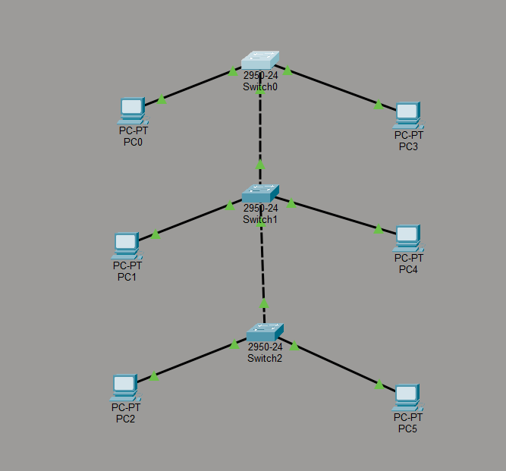

Output:

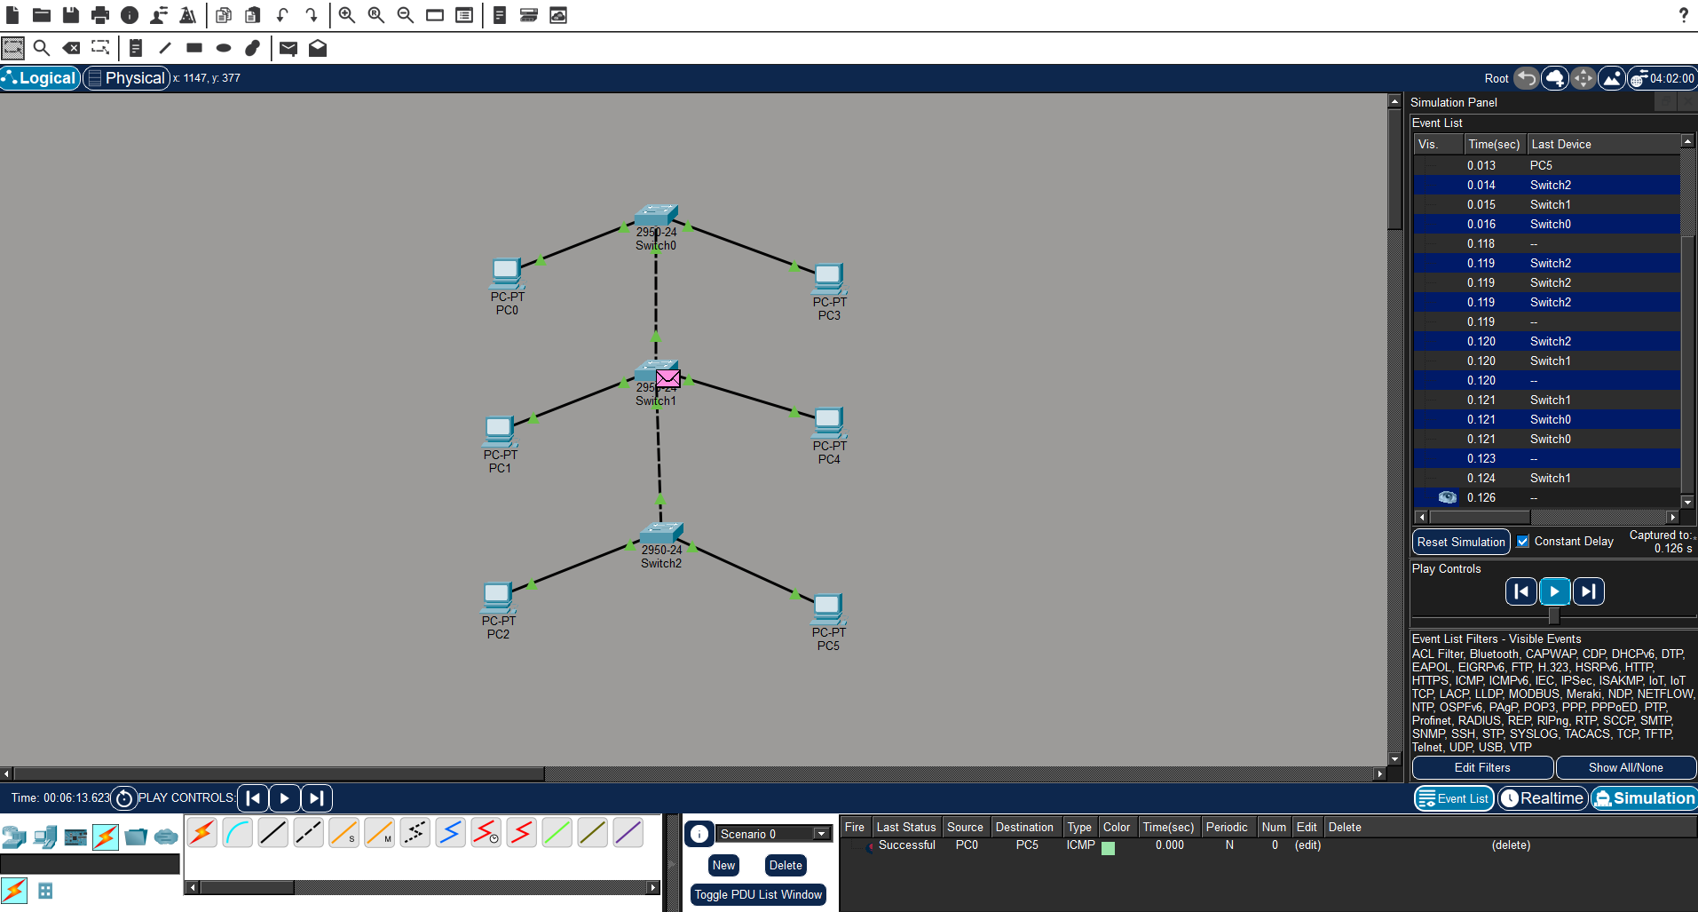
output:

Result: Thus the Tree topology is implemented with Packet Tracer simulation Tool.

Date:

EXPERIMENT-7
IMPLEMENTATION OF HYBRID TOPOLOGY (BUS AND RING TOPOLOGY) USING PACKET TRACER

Aim: To Implement a hybrid topology using packet tracer and hence to transmit data between the devices connected using tree topology.
Software / Apparatus required: Packet Tracer / End devices, Hubs, connectors.
Steps for building topology:
Step 1: Start Packet Tracer
Step 2: Choosing Devices and Connections Step 3: Building the Topology – Adding Hosts
Single click on the End Devices. Single click on the Generic host. Move the cursor into topology area.
Single click in the topology area and it copies the device.
Step 4: Building the Bus Topology – Connecting the Hosts to Hubs Select a Hub, by clicking once on Hub and once on a generic Hub Add the Hub by moving the plus sign “+”
Step 5: Building the Ring Topology – Connecting the Hosts to Hubs Select a Hub, by clicking once on Hub and once on a generic Hub Add the Hub by moving the plus sign “+”

Step 5: Connect PCs to Hub by first choosing Connections
Click once on the Automatic cable selector
Click once on PC2 Choose Fast Ethernet Drag the cursor to Hub0 Click once on Hub0

Proceeding in this way create three Bus topologies
Step 6: Building the Tree Topology – Connecting the Hubs to Active Hub
Connect the hubs of star topologies to active hub to create tree topology.

Step 7: Configuring IP Addresses and Subnet Masks on the Hosts
To start communication between the hosts IP Addresses and Subnet Masks had to be configured on the devices. Click once on PC0. Choose the Config tab and click on FastEthernet0. Type the IP address in its field. Click on the subnet mask. It will be Generated automatically.

Step 8: Verifying Connectivity in Realtime Mode
Be sure you are in Realtime mode.
Select the Add Simple PDU tool used to ping devices. Click once on PC0, then once on PC3.
The PDU Last Status should show as Successful.

Step 9: Verifying Connectivity in Simulation Mode
Be sure you are in Simulation mode.
Deselect all filters (All/None) and select only ICMP. Select the Add Simple PDU tool used to ping devices Click once on PC0, then once on PC3.
Continue clicking Capture/Forward button until the ICMP ping is completed. The ICMP messages move between the hosts, hub and switch. The PDU Last Status should show as Successful.

Diagram:

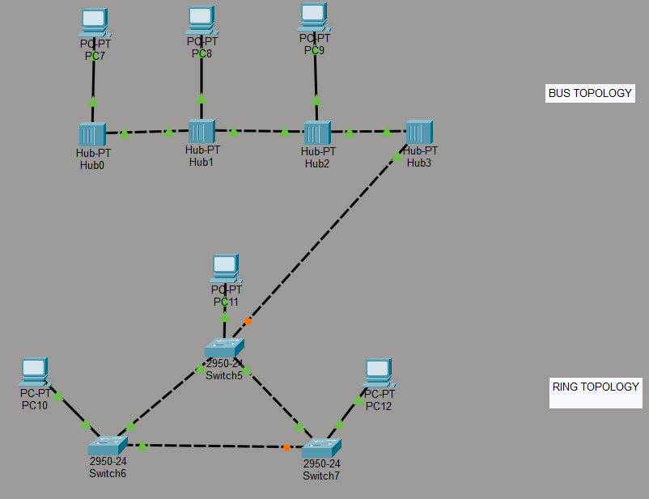

Output:

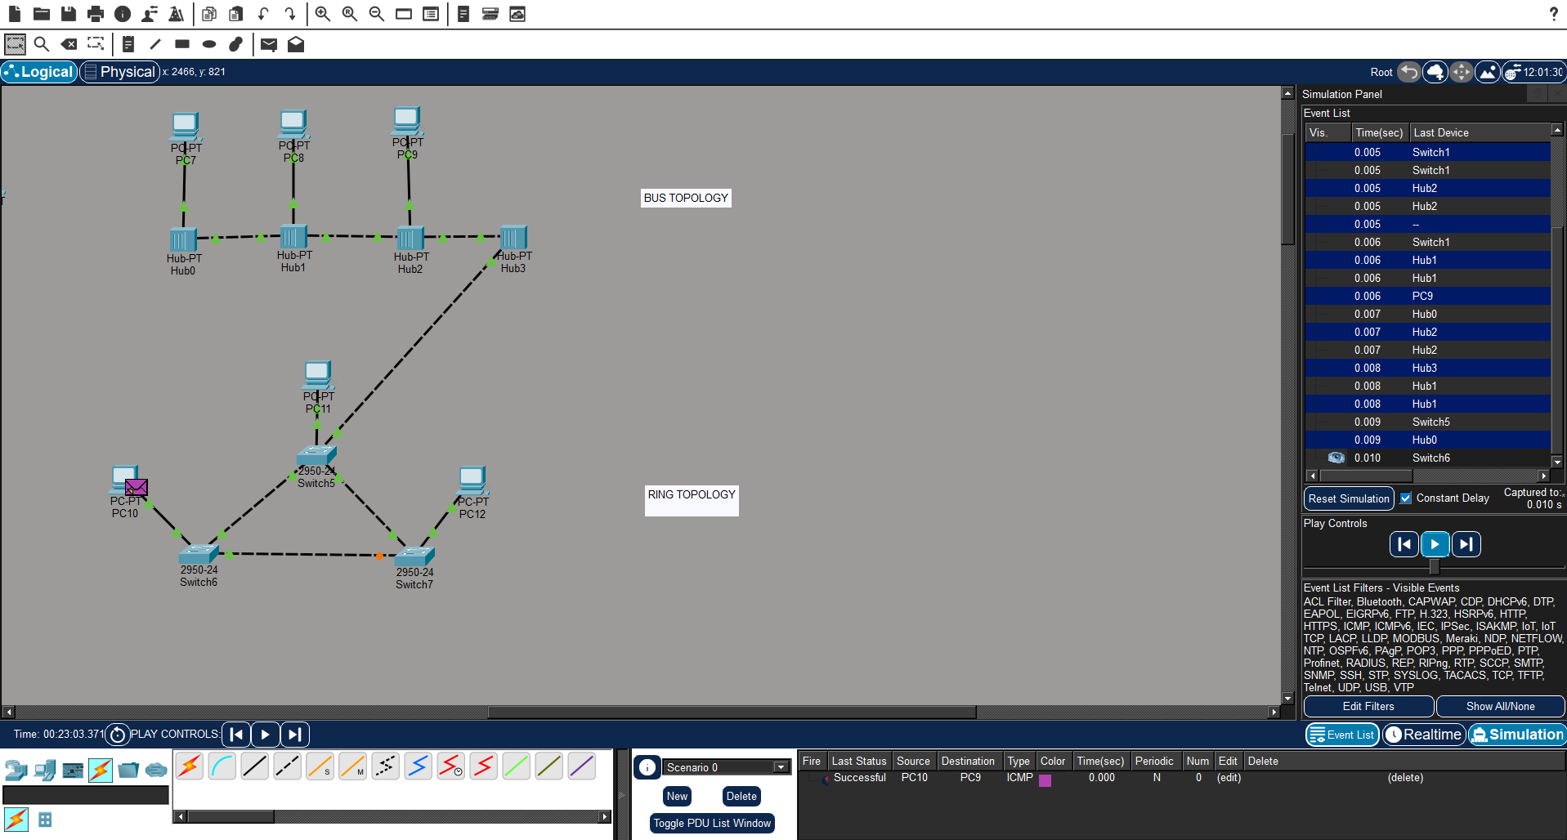

Result: Thus the Hybrid topology is implemented with Packet Tracer simulation Tool.

